**Student Marks Prediction Machine Learning Project**

## *Objectives*

Education is very important issue regarding development of a country. The main objective of educational institutions is to provide high quality education to its students. One way to accomplish this is by predicting student's academic performance and thereby taking early steps to improve student's performance and teaching quality.

 This system aims to predict student's marks using linear regression. The idea behind this analysis is to predict the marks of students by their studying hours.Through this project we can determine:

* How many hours need to do the study to get 99% marks
* If I will do study x() hours per day so how much marks I will get

Through these points the school/College can determine the performance of the student.

## *Student marks Prediction model.*

I created a student marks prediction model with the help of following few steps like :

1. Define project objectives

2. Data Preprocessing (Data Cleaning , Data Preparation , split into train and test , Feature Scaling).

3. Model Selection

4. Data Collection

5. Data Visualization

6. Model Building

7. Deploy Model

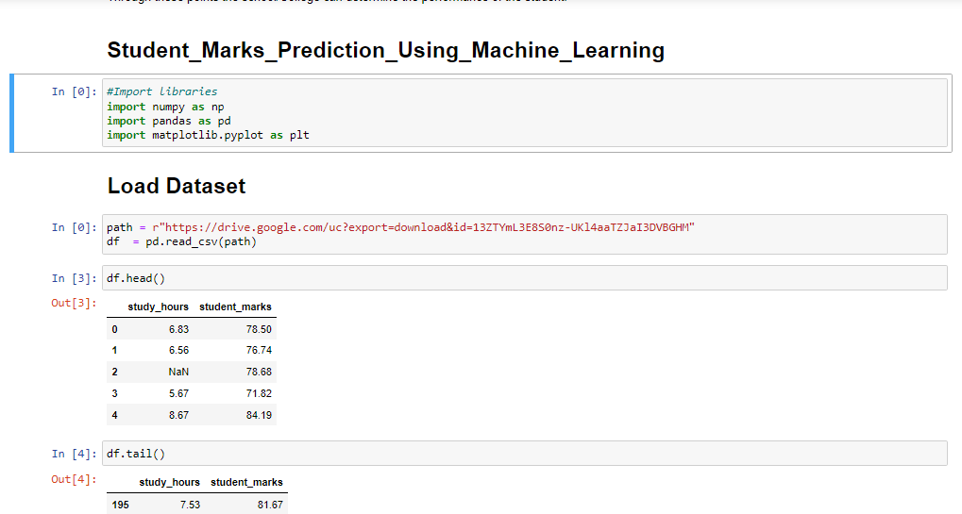

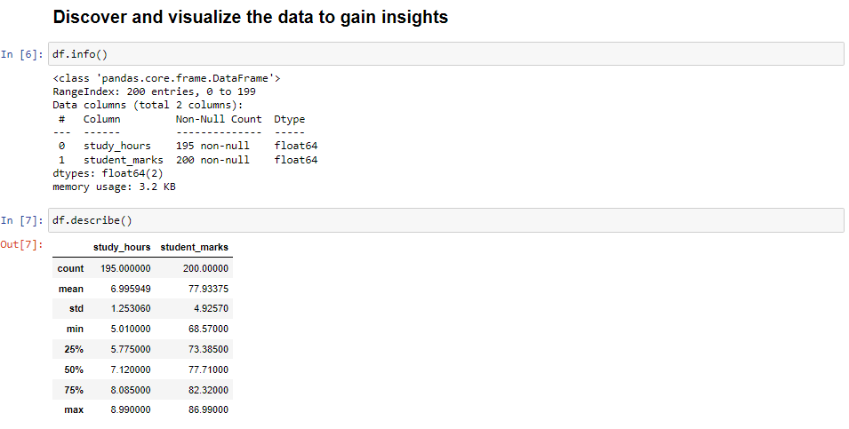

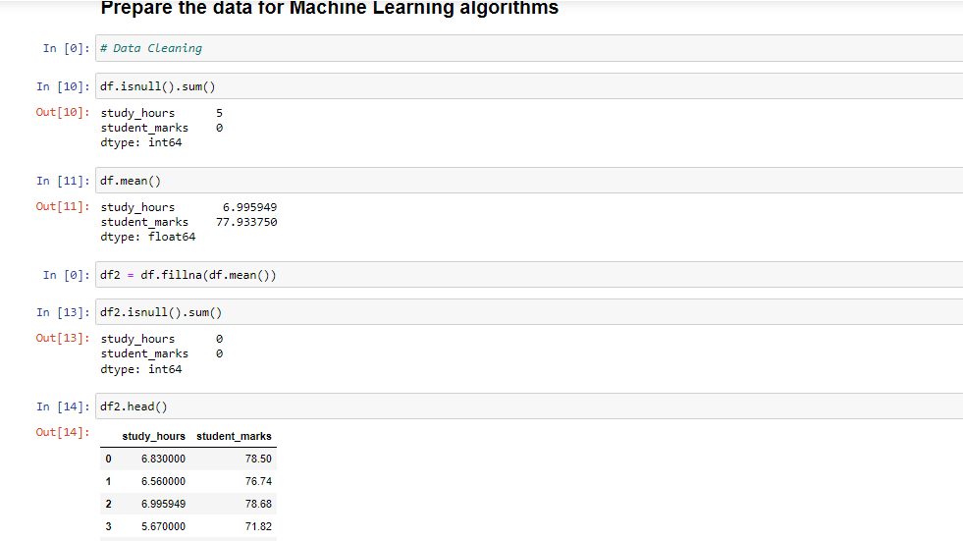

And i also used a model with my flask application.

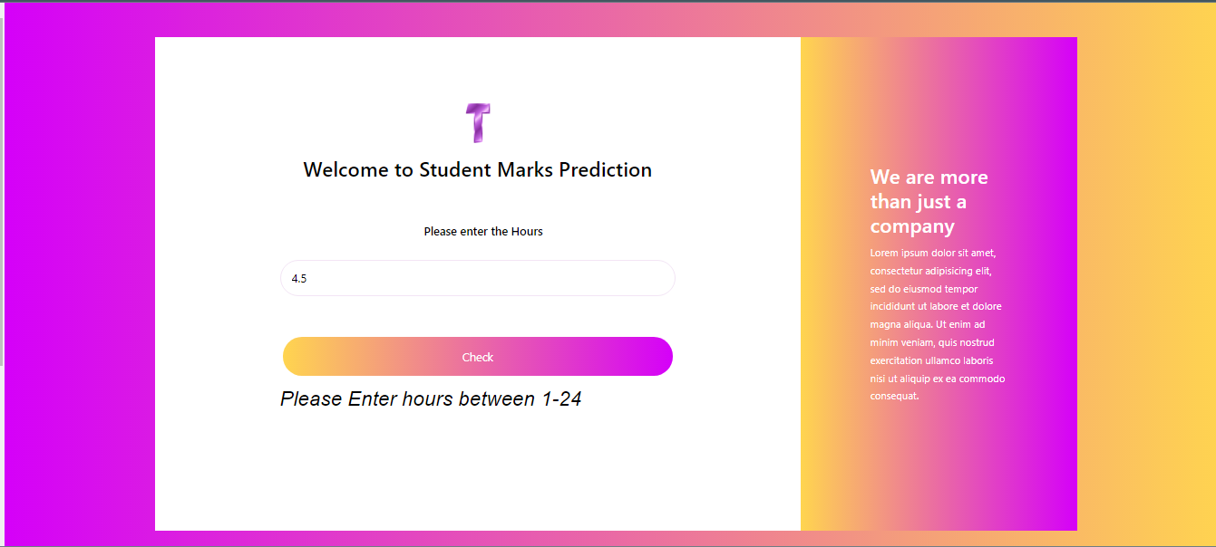

And i also deploy this model on heroku.

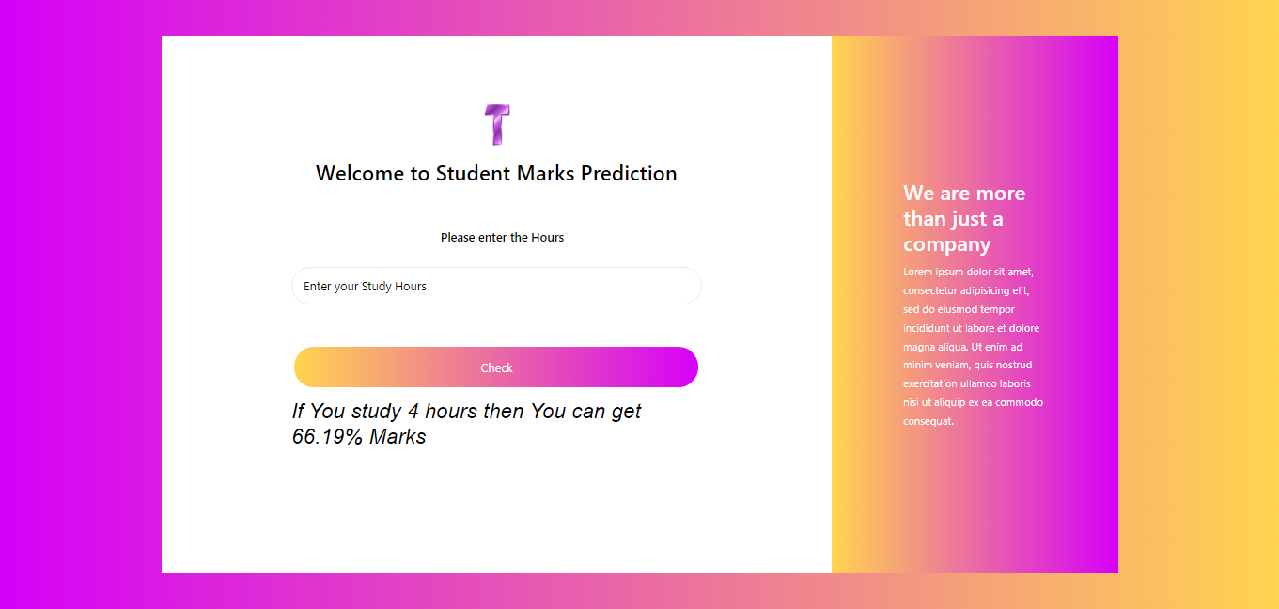

## *Source code and how to use:*

1. Go to my github  and download code : [Student Marks Prediction](https://github.com/Praveen0310/Student_Marks_Prediction_Machine_Learning)

2. After download, Extract the folder.

3. You will find the model

***Deployment on heroku.***

Website Link : [Student Marks Prediction on heroku](https://student-marks-prediction02.herokuapp.com/)